

**Avalanche Innovation Team:**

Nishan Subba - Database Administrator

Aman Gurung - Data/Business Analyst I

Chiagoziem Igwe - Data/Business Analyst II

Dhulfiqar Hussein - Lead Developer I, Full Stack

Harshitha Sayini - Developer II, Full Stack

Trevin Nisbett - Project Manager, Quality Assurance

Professor: Shiva Sharma - IS436 Structured Systems Analysis and Design

Date: Nov 05, 2023

Deliverable Name: Project Deliverable 3 - Process Modeling - Gorilla Distribution Center's Payroll Modernization

# Process Modeling - Gorilla Distribution Center's Payroll Modernization

**Process Modeling - Gorilla Distribution Center's Payroll Modernization 2**

**Context Diagram and DFDs 3**

Key 3

Context Diagram - Payroll System 4

Process 1 - Manage Employee Info 5

Process 2 - Process Payroll 6

Process 3 - Generate Payroll Reports 7

Process 4 - Manage Benefits and Deductions 8

Process 5 - Handle Overtime Requests 9

Process 6 - Comply with Legal Requirements 10

**Data Flow Explanation 11**

Definitions 11

**Updated Use Cases 12**

Use Case 1: Manage Employment 12

Use Case 2: Process Payroll 13

Use Case 3: Generate Payroll Report 15

Use Case 4: Manage Benefits and Deductions 17

Use Case 5: Handle Overtime Requests 18

New Use Case 20

Use Case 8: Authenticate User Login 20

Use Case 9: Register User Account 21

Use Case 10: Terminate Employee Record 22

Use Case 7: Update Student Account 23

Use Case 12: Check Personal Payroll Report 24

**Updated Project Plan GitHub 26**

**Team Member Information 26**

Trevin Nisbett - Project Manager, Quality Assurance 26

Dhulfiqar Hussein - Lead Developer I, Full Stack 26

Harshitha Sayini - Developer II, Full Stack 27

Nishan Subba - Database Administrator 27

Aman Gurung - Data/Business Analyst I 27

Chiagoziem Igwe - Data/Business Analyst II 27

**Meeting Time 28**

Contact US 28

# Context Diagram and DFDs

## Key

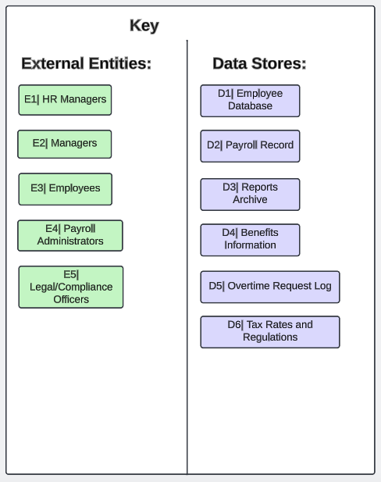

## Context Diagram - Payroll System

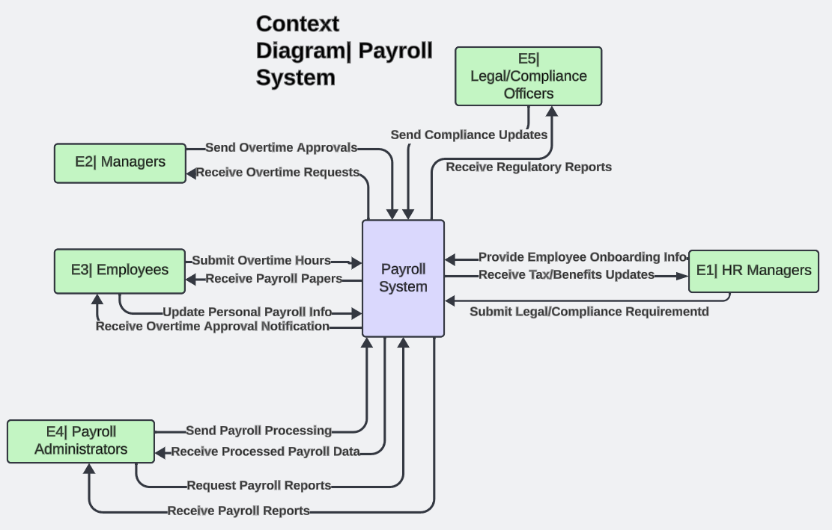

## Process 1 - Manage Employee Info

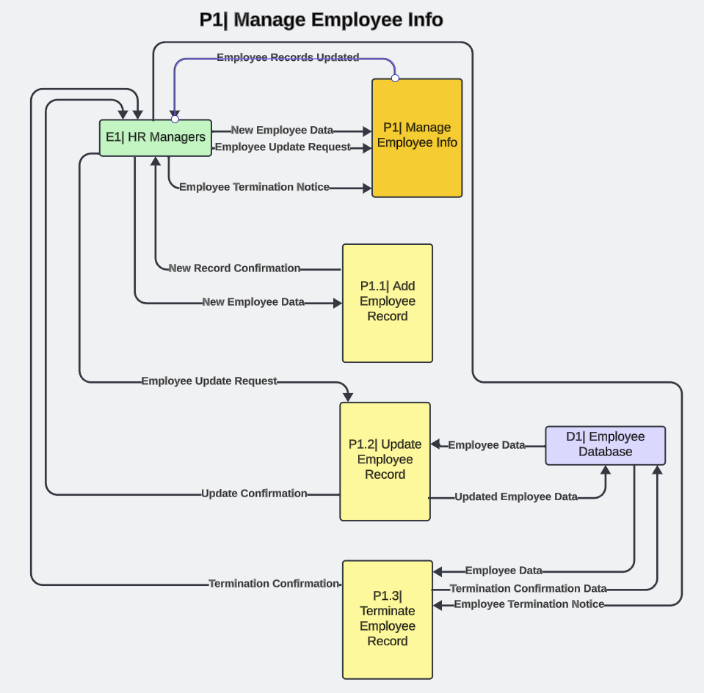

## Process 2 - Process Payroll

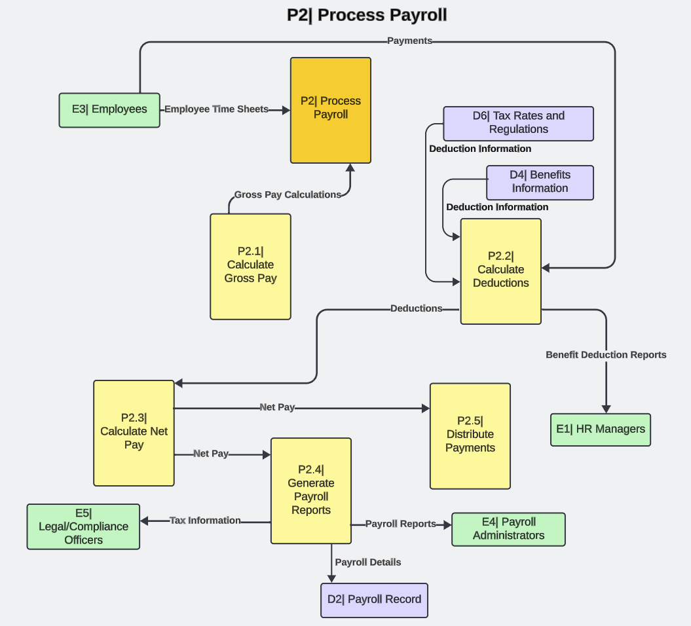

## Process 3 - Generate Payroll Reports

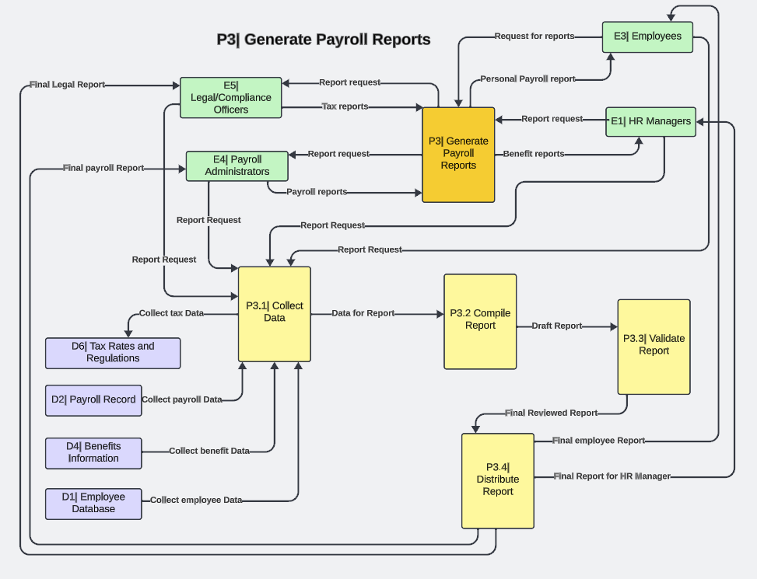

## Process 4 - Manage Benefits and Deductions

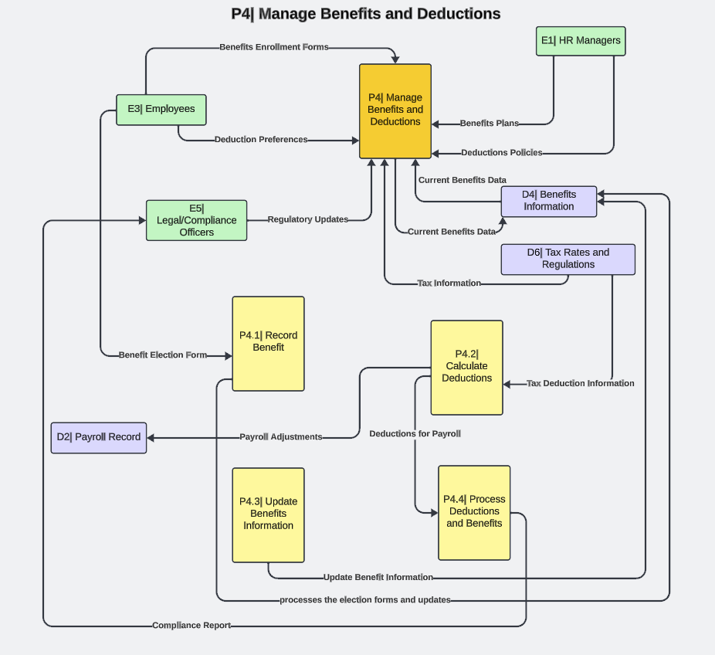

## Process 5 - Handle Overtime Requests

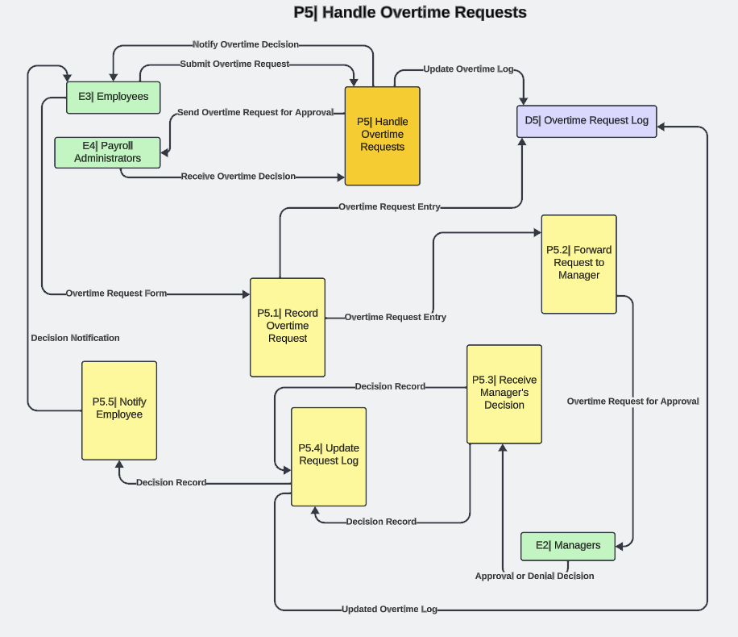

## Process 6 - Comply with Legal Requirements

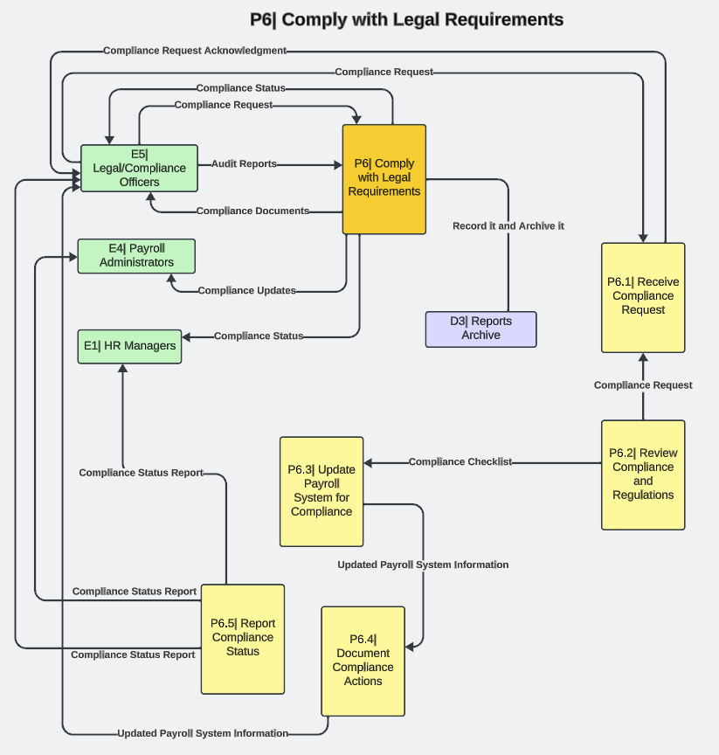

# Data Flow Explanation

## 

## Definitions

Process:

**Employee info management:** The process of adding, updating, or terminating an employee record in the employee database.

**Process payroll:** Compensating employees by calculating wage earnings and deductions.

**Generate payroll:** The process of collecting payroll data, compiling and validating the payroll report, and distributing it.

**Manage benefits and deductions:** Employees will record their benefits and deductions will be calculated.

**Handle overtime requests:** Employees submit an overtime request which is recorded and forwarded to the manager, a decision will be received, the request log is updated, and then the employee is notified.

**Comply with legal requirements:** A compliance request is received and reviewed. Payroll is updated the compliance action is documented and the status will be reported.

Entities:

**HR managers:** Responsible for managing employee information, and generating payroll reports.

**Manager:** Send and receive overtime approvals.

**Employees:** Submit overtime hours and update personal payroll info.

**Payroll administrators:** Work with the HR department to generate reports and assist employees with their pay.

**Legal/compliance officers:** Comply with legal requirements of the payroll process.

Datastore:

**Employee database:** Tracks employee information.

**Payroll record:** Documentation of payment of employees.

**Reports archive:** Reports are recorded and archived.

**Benefits information:** Calculating the benefits of an employee's pay.

**Overtime request log:** Employee overtime hours are recorded and their pay is distributed accordingly.

**Tax rates and regulations:** Social Security and Medicare tax.

Dataflow:

**E1:** HR manager inputs employee onboarding info and submits legal/compliance requirements. Output from the payroll system is the tax/benefits update.

**E2:** Managers input overtime approvals and the output from the payroll system allows managers to receive overtime requests.

**E3:** Employees input overtime hours and update personal payroll info. The output is payroll papers and an overtime approval notification sent to employees.

**E4:** Payroll administrators input payroll processing and request payroll reports. The payroll system outputs processed payroll data and reports.

**E5:** Legal/compliance officers input compliance updates and the payroll system outputs regulatory reports.

# Updated Use Cases

### Use Case 1: Manage Employment

|  |  |
| --- | --- |
| **Use Case ID:** | UC-02 |
| **Use Case Name:** | Manage Employee |
| **Actor:** | HR Manager and Employee |
| **Description:** | This use case covers the addition of a new employee and the deletion or update of a former employee to the system. |
| **Preconditions:** | * HR Manager is logged in. * Necessary employee information is available. |
| **Post Conditions:** | New employee's data is added to the system. Employee information is updated or deleted. |
| **Priority:** | Medium |
| **Frequency of Use:** | As needed |
| **Normal Course of Events:** | * HR Manager logs in. * Select the option to add a new employee. * Select the option to remove an employee. * Enter employee details. * The system validates the information. * The system adds the new employee to the database. * Update employee records. |
| **Alternative Courses:** | None |
| **Exception:** | * Step 4: If the information is incomplete or contains errors, the system prompts the HR Manager to correct it. |
| **Includes:** | None |
| **Special Requirements:** | None |
| **Assumptions:** | * HR Manager has access to accurate employee information. |

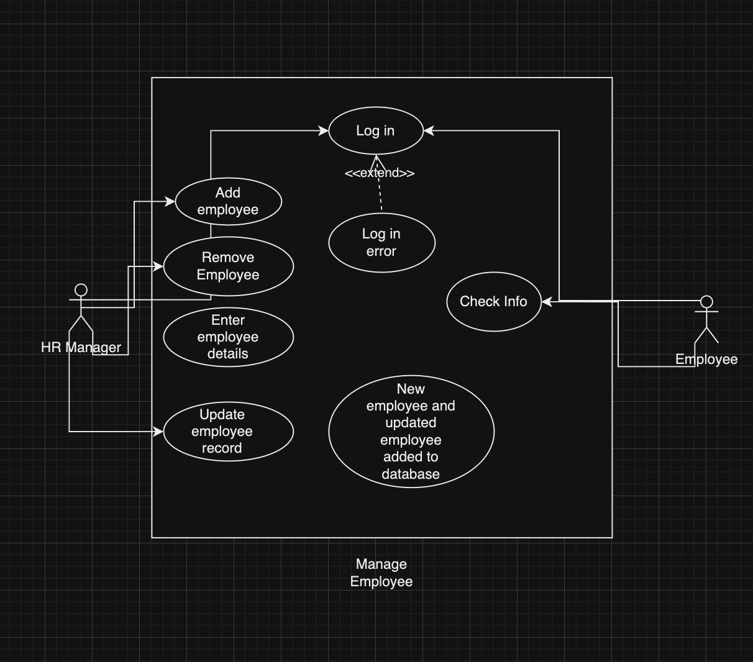

### Use Case 2: Process Payroll

|  |  |
| --- | --- |
| **Use Case ID:** | UC-01 |
| **Use Case Name:** | Process Payroll |
| **Actor:** | Payroll Administrator, HR Manager, and Employee |
| **Description:** | This use case represents the process of calculating and disbursing employee salaries. |
| **Preconditions:** | * Payroll data for the current pay period is collected and validated. * Employee information is up-to-date. |
| **Post Conditions:** | * Employee salaries are calculated and stored. * Payments are made to employees. |
| **Priority:** | High |
| **Frequency of Use:** | Biweekly or Monthly |
| **Normal Course of Events:** | * Payroll administrator logs in. * Employee logs in. * Both Select the pay period. * System calculates salaries for all employees. * Employee checks his gross pay and time sheet. * Administrator reviews and approves the calculated payroll. * Payments are processed and disbursed to employees. |
| **Alternative Courses:** | Step 4: If the administrator identifies errors, they can correct them and pre-approve the payroll. |
| **Exception:** | Step 3: If there are missing or incorrect employee data, the system alerts the administrator to update the data before proceeding. |
| **Includes:** | None |
| **Special Requirements:** | Secure payment processing system |
| **Assumptions:** | All employee information is accurate and up-to-date. |

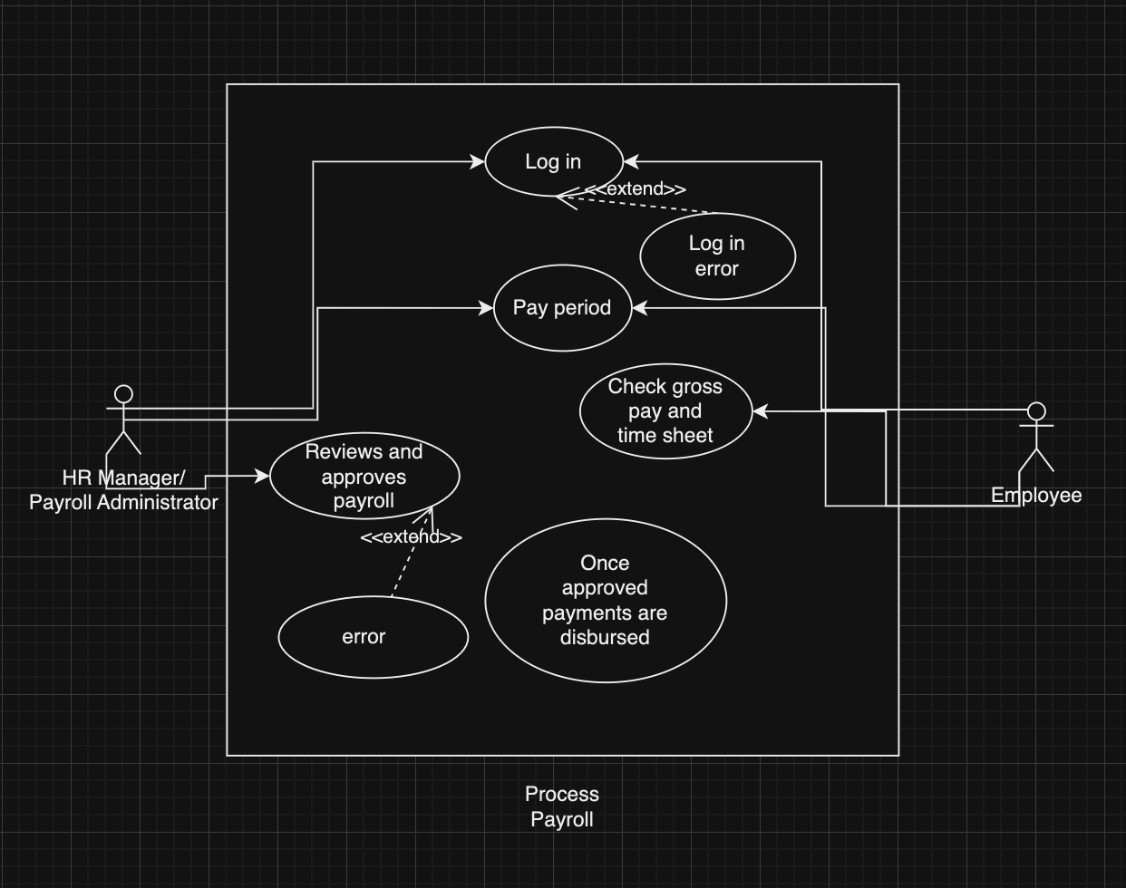

### Use Case 3: Generate Payroll Report

|  |  |
| --- | --- |
| **Use Case ID:** | UC-03 |
| **Use Case Name:** | Generate Payroll Report |
| **Actor:** | Payroll Administrator, HR Manager, and Employee |
| **Description:** | This use case involves generating payroll reports for accounting and record-keeping purposes. |
| **Preconditions:** | Payroll data is processed and stored. |
| **Post Conditions:** | Payroll report is generated and saved. |
| **Priority:** | Medium |
| **Frequency of Use:** | Monthly |
| **Normal Course of Events:** | * Payroll administrator logs in. * The HR manager can log in to check the report. * Employees can also check their personal report. * Select the desired pay period. * Generates the payroll report. * Saves the report to the specified location. |
| **Alternative Courses:** | None |
| **Exception:** | None |
| **Includes:** | None |
| **Special Requirements:** | Access to report templates. |
| **Assumptions:** | Payroll data is accurate and up-to-date. |

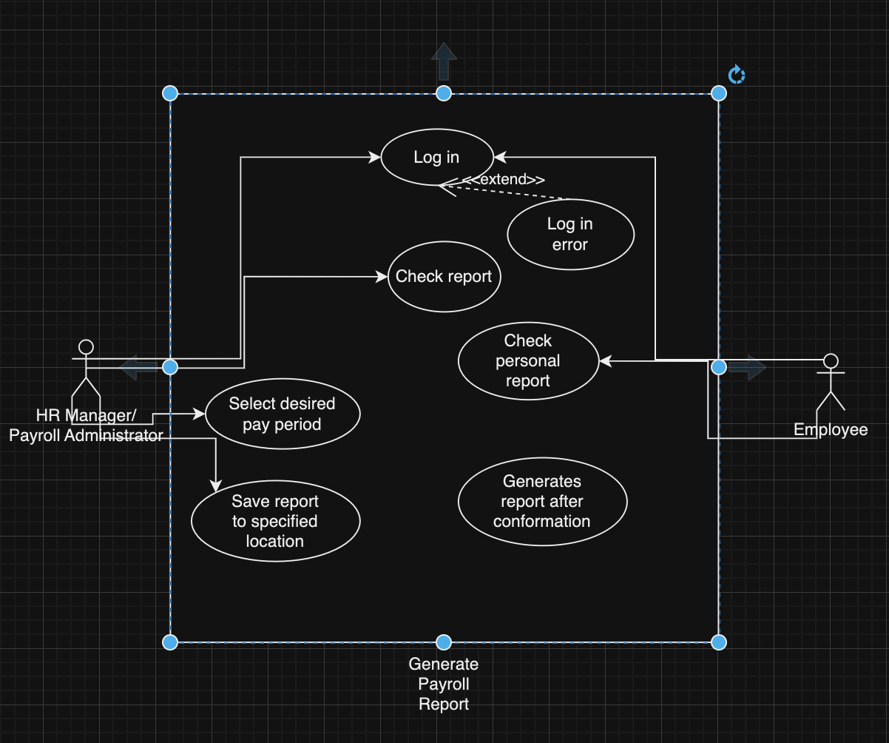

### Use Case 4: Manage Benefits and Deductions

|  |  |
| --- | --- |
| **Use Case ID:** | UC-04 |
| **Use Case Name:** | Deductions and Benefits Calculation |
| **Actor:** | Payroll Administrator and Employee |
| **Description:** | This use case represents the process of calculating and managing employee deductions and benefits. |
| **Preconditions:** | * Payroll data is processed and stored. * Deductions and benefits information is up-to-date. |
| **Post Conditions:** | Deductions and benefits are applied to employee salaries. |
| **Priority:** | High |
| **Frequency of Use:** | Biweekly or Monthly |
| **Normal Course of Events:** | * Payroll administrator logs in. * Select the pay period. * Calculates and applies deductions and benefits. * Updates employee salaries with the changes. * Employees can log in to check their benefits. |
| **Alternative Courses:** | Step 3: If there are errors in calculation, the administrator can make corrections. |
| **Exception:** | None |
| **Includes:** | None |
| **Special Requirements:** | Accurate deductions and benefits data. |
| **Assumptions:** | Payroll data and deductions/benefits information are accurate and up-to-date. |

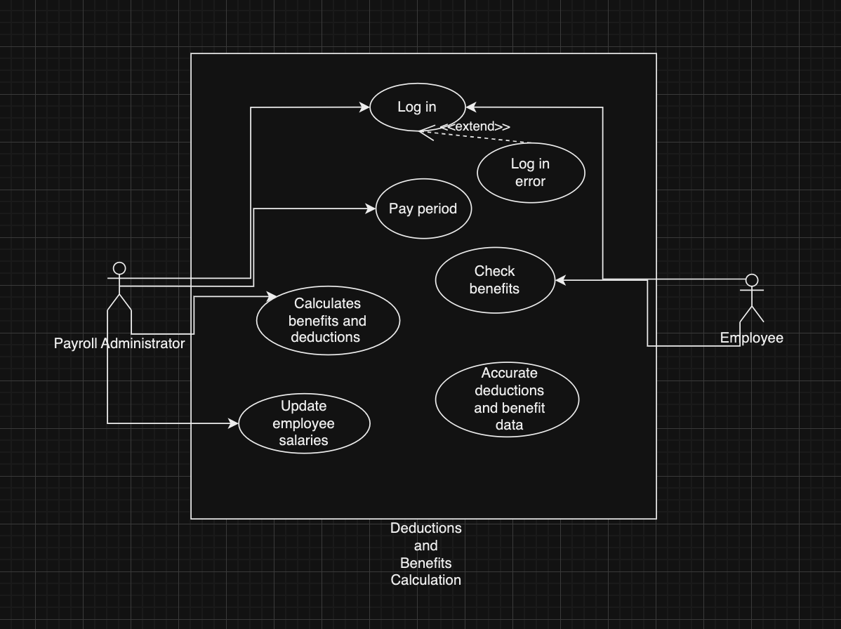

### Use Case 5: Handle Overtime Requests

|  |  |
| --- | --- |
| **Use Case ID:** | UC-06 |
| **Use Case Name:** | Overtime Approval |
| **Actor:** | Manager and Employee |
| **Description:** | This use case represents the approval process for employee overtime hours |
| **Preconditions:** | * Overtime requests are submitted by employees. * Managers are logged in. |
| **Post Conditions:** | Overtime requests are either approved or denied. |
| **Priority:** | High |
| **Frequency of Use:** | As needed |
| **Normal Course of Events:** | * Manager logs in. * Views pending overtime requests. * Approves or denies requests. * The system notifies the employees of the decision. * Employee logs in. * Requests for overtime. * Gets their decision once the manager makes their decision. |
| **Alternative Courses:** | None |
| **Exception:** | None |
| **Includes:** | None |
| **Special Requirements:** | Integration with employee scheduling systems. |
| **Assumptions:** | Overtime requests are submitted by employees accurately. |

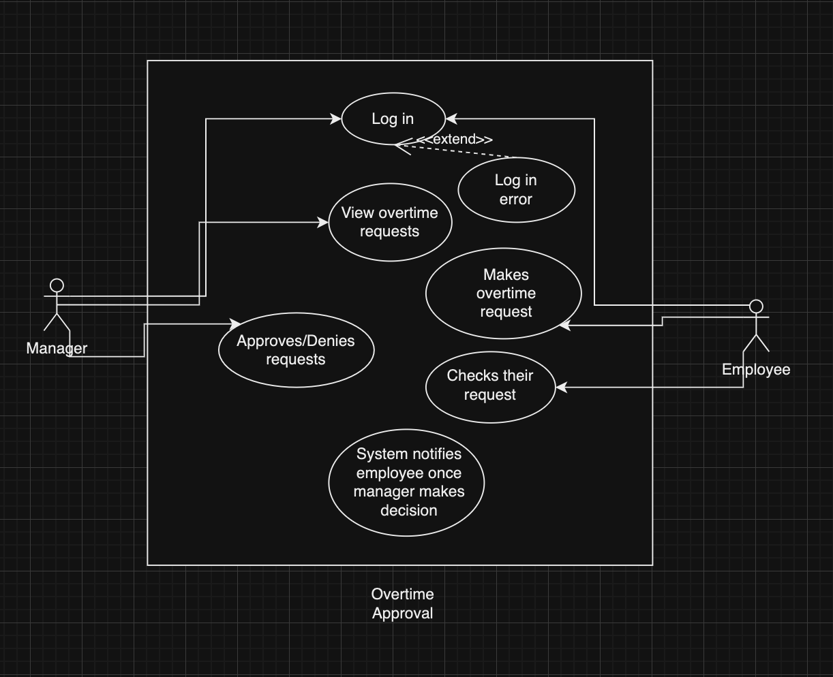

## New Use Case

### Use Case 8: Authenticate User Login

|  |  |
| --- | --- |
| ID: | UC-8 |
| Title: | Authenticate User Login |
| Description: | This use case describes the process by which a user is authenticated when attempting to access the payroll system. The system will validate the user credentials against the stored user information in the database to grant or deny access. |
| Trigger: | The user initiates a login attempt to the payroll system. |
| Primary Actor: | User (Employee, Manager, HR, or Payroll Administrator) |
| Secondary Actor: | Database |
| Preconditions: | * The payroll system login page is accessible to the user. * The authentication server is operational. |
| Postconditions: | * If authentication is successful, the user gains access to the system based on their role and permissions. * If authentication fails, the user is informed and may be given the option to retry or recover their credentials. |
| Main Success Scenario: | 1. The user navigates to the payroll system login page. 2. The user enters their username and password. 3. The system validates the credentials against the authentication server. 4. The system grants access and directs the user to their dashboard. |
| Extensions: | 3a. If the user enters invalid credentials:   1. The system displays an error message. 2. The user can attempt to log in again or use a password recovery option.   3b. If the authentication server is not responding:   1. The system logs the error and alerts the system administrator. 2. The user is informed of a technical issue. |
| Frequency of Use: | Multiple times daily |
| Status: | In Development |
| Owner: | Nishan Subba, Avalanche Innovation |
| Date Created: | November 5, 2023 |
| Priority: | High |

### Use Case 9: Register User Account

|  |  |
| --- | --- |
| ID: | UC-9 |
| Title: | Register User Account |
| Description: | This use case describes the steps a new user follows to create an account in the payroll system, allowing them to access and manage their payroll information securely. |
| Trigger: | A new user needs to create an account to use the payroll system. |
| Primary Actor: | New User (Employee, Manager, or HR Personnel) |
| Secondary Actor: | Authentication Server |
| Preconditions: | * The user has valid employment credentials or authorization to access the payroll system. * The registration page is available and functional. |
| Postconditions: | * The user's account is created in the system. * The user can log in to the payroll system with their new credentials. |
| Main Success Scenario: | * The new user navigates to the payroll system's registration page. * The user selects the option to create a new account. * The user provides the required information, such as name, employment ID, and email address, and creates a password. * The system validates the provided information and creates a new user account. * The user's account becomes active, and they are directed to the login page. |
| Extensions: | 4a. If the user provides incomplete or invalid information:   1. The system displays an error message. 2. The user is prompted to correct the information.   4b. If the user's employment ID does not match company records:   1. The system alerts the user and prevents account creation. 2. The user is instructed to contact HR for assistance. |
| Frequency of Use: | Multiple times daily |
| Status: | In Development |
| Owner: | Nishan Subba, Avalanche Innovation |
| Date Created: | November 5, 2023 |
| Priority: | High |

### Use Case 10: Terminate Employee Record

|  |  |
| --- | --- |
| ID: | UC-10 |
| Title: | Terminate Employee Record |
| Description: | This use case details the process for formally removing an employee's record from the company's payroll system. |
| Trigger: | HR confirms an employee's termination or resignation. |
| Primary Actor: | HR Manager |
| Secondary Actor: | Payroll System |
| Preconditions: | * The employee has been formally notified of their termination or has resigned. * HR has completed all necessary paperwork and procedures for employee termination. |
| Postconditions: | * The employee's record is marked as inactive or removed from the payroll system. * The employee no longer has access to the payroll system. * Final payments, severance, or benefits have been processed as applicable. |
| Main Success Scenario: | 1. HR Manager logs into the payroll system with administrator privileges. 2. The HR Manager navigates to the employee's record. 3. The HR Manager initiates the termination process in the system. 4. The system prompts for confirmation and any final payout details. 5. The HR Manager confirms termination and enters any final payout information. 6. The system processes the termination and updates the employee's record to reflect their departure. 7. The system generates a termination report for records and compliance. |
| Extensions: | 5a. If there are disputes or pending issues regarding the final payout:   1. HR Manager puts the termination process on hold. 2. The HR Manager resolves disputes before finalizing the termination.   6a. If the system detects an error during the process:   1. The system alerts the HR Manager. 2. The HR Manager reviews the details and corrects any issues. |
| Frequency of Use: | Multiple times daily |
| Status: | In Development |
| Owner: | Nishan Subba, University Library Team |
| Date Created: | October 6, 2023 |
| Priority: | High |

### Use Case 7: Update Student Account

|  |  |
| --- | --- |
| ID: | UC-11 |
| Title: | Calculate Pay for Period |
| Description: | This use case describes the process for calculating the pay for employees for a specific period, including all applicable wages, overtime, bonuses, deductions, and benefits. |
| Trigger: | The end of a pay period (e.g., weekly, bi-weekly, monthly). |
| Primary Actor: | Payroll Administrator |
| Secondary Actor: | Payroll System, HR Manager (for verifying and approving pay calculations) |
| Preconditions: | * All employee time tracking data is up-to-date. * Current rates for wages, overtime, and bonuses are entered into the system. * Deduction and benefit rates are current and accurate. |
| Postconditions: | * Employee pay for the period has been accurately calculated. * Payroll records are updated to reflect the current pay period's calculations. * Pay calculations are ready for review and approval. |
| Main Success Scenario: | 1. The Payroll Administrator logs into the payroll system. 2. The Payroll Administrator selects the pay period for calculation. 3. The system retrieves all relevant employee time data and current rates. 4. The system calculates gross pay, applies deductions, and adds benefits. 5. The system presents a summary of the pay calculations for the Payroll Administrator's review. 6. The Payroll Administrator reviews, adjusts if necessary, and approves the pay calculations. 7. The system updates payroll records with the approved pay calculations. |
| Extensions: | 5a. If the Payroll Administrator finds discrepancies:   1. The Payroll Administrator adjusts the data entries. 2. The system recalculates the pay for the affected employees.   6a. If the HR Manager needs to approve the calculations:   1. The Payroll Administrator submits the calculations for HR Manager approval. 2. HR Manager reviews and approves the calculations. |
| Frequency of Use: | Multiple times daily |
| Status: | In Development |
| Owner: | Nishan Subba, University Library Team |
| Date Created: | October 6, 2023 |
| Priority: | High |

### Use Case 12: Check Personal Payroll Report

|  |  |
| --- | --- |
| ID: | UC-12 |
| Title: | Check Personal Payroll Report |
| Description: | This use case details the process by which an employee can review their payroll report, which includes their earnings, deductions, and net pay for a specific pay period. |
| Trigger: | An employee wishes to review their payroll details for personal record-keeping or verification purposes. |
| Primary Actor: | Employee |
| Secondary Actor: | Payroll System, HR Department |
| Preconditions: | * The employee has access to the employee self-service portal. * Payroll data for the relevant period is accurate and updated in the system. |
| Postconditions: | * The employee has accessed and reviewed their personal payroll report. * Any discrepancies noted by the employee are reported to the HR department for correction. |
| Main Success Scenario: | 1. Employees log into the self-service portal using their credentials. 2. Employee navigates to the 'My Reports' section. 3. Employee selects the pay period they wish to review. 4. The system retrieves the relevant payroll data and displays the report. 5. Employee reviews the report for accuracy. 6. The employee logs out of the portal. |
| Extensions: | 5a. If the employee finds discrepancies:   1. Employee contacts HR for clarification. 2. HR reviews the report, makes necessary corrections, and updates the employee. |
| Frequency of Use: | Multiple times daily |
| Status: | In Development |
| Owner: | Nishan Subba, University Library Team |
| Date Created: | October 6, 2023 |
| Priority: | High |

# Updated Project Plan GitHub

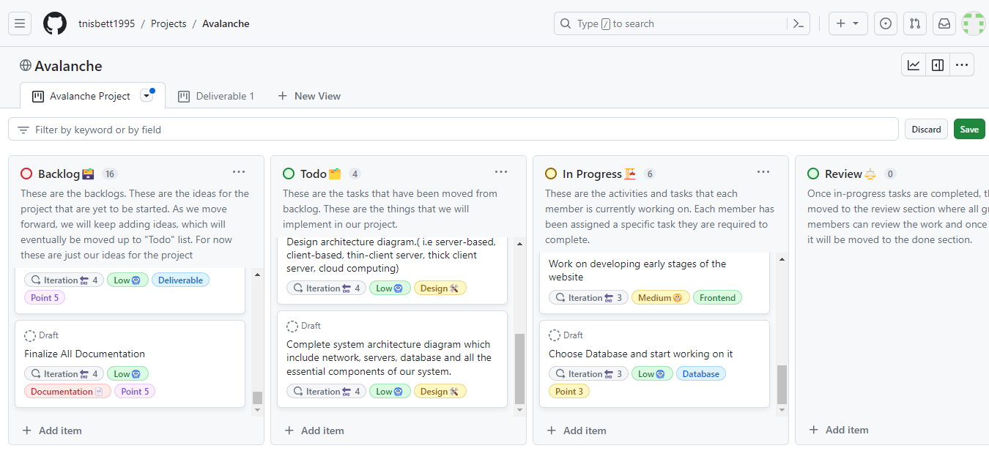

<https://github.com/users/tnisbett1995/projects/3/views/1?layout=board>

# Team Member Information

## Trevin Nisbett - Project Manager, Quality Assurance

I am Trevin Nisbett, and I will be the Project Manager for this project. I have experience in Java, SQL, and Excel. I am excited to work on this project and apply my technical skills to the Avalanche Innovation team to have a successful digital payroll system.

For questions or inquiries, please contact me at

Email: [tnisbet1@umbc.edu](mailto:tnisbet1@umbc.edu)

Github: tnisbett1995

## Dhulfiqar Hussein - Lead Developer I, Full Stack

Hello, My name is Dhulfiqar Hussein and I will serve as a full-stack lead developer alongside Harshitha. I have experience in the following areas, SQL, HTML, CSS, JAVASCRIPT, Python, C++, and PHP. I am excited to collaborate with the team and share my technical skills to drive the success of our digital payroll system project.

For questions or inquiries, please contact me at

Email: [dhussei1@umbc.edu](mailto:dhussei1@umbc.edu)

Github: DhulfiqarH

## Harshitha Sayini - Developer II, Full Stack

I am Harshitha Sayini and I will serve as a full-stack developer alongside Dhulfiqar. I have experience working with SQL, HTML, Java, CSS Javascript, and Excel. I will be using my programming skills to aid in the development of our web application for Avalanche Innovation. As a team, we will be committed to creating an application that will be accessible to all users.

For questions or inquiries, please contact me at

Email: [hsayini1@umbc.edu](mailto:hsayini1@umbc.edu)

Github: hsayini7078

## Nishan Subba - Database Administrator

I'm Nishan, and I serve as the Database Administrator for our project. With a strong background in data management and experience in SQL, Python, and Excel, I've had the privilege of working with various databases, including Oracle and MySQL. My passion lies in extracting stories from data and transforming raw information into actionable insights. I'm committed to bringing my data expertise to the Avalanche Innovation team to ensure the success of our digital payroll system project.

For questions or inquiries, please contact me at

Email: [nsubba1@umbc.edu](mailto:nsubba1@umbc.edu)

Github: nissubba1

## Aman Gurung - Data/Business Analyst I

My name is Aman and I will serve as a Data/Business Analyst I for this project. I have experience in SQL, Statistics in Business and Econ, Excel, and Python. I am skilled in producing insightful data visualizations and reports that provide our company with the information they need to make wise decisions.

For questions or inquiries, please contact me at

Email: [amang2@umbc.edu](mailto:amang2@umbc.edu)

Github: Aman440501

## Chiagoziem Igwe - Data/Business Analyst II

My name is Chiagoziem Igwe, and I will serve as a Data and Business Analyst II for this project.

For questions or inquiries, please contact me at

Email: [chiagoi1@umbc.edu](mailto:chiagoi1@umbc.edu)

Github: chiaigwe

# Meeting Time

Weekly Meeting:

Every Sunday @ 8 PM

## Contact US

For any inquiries or additional information related to this proposal, please get in touch with our key project members:

Trevin Nisbett

*Project Manager, Quality Assurance*

Email: [tnisbet1@umbc.edu](mailto:tnisbet1@umbc.edu)

As the Project Manager, Trevin oversees the entire project, ensuring milestones are met, quality is maintained, and all team members collaborate effectively. For any project/proposal inquiry, Trevin is your go-to contact.

Aman Gurung

*Data/Business Analyst I*

Email: [amang2@umbc.edu](mailto:amang2@umbc.edu)

Aman, our Data/Business Analyst I, dives deep into the specifics of the payroll system, ensuring that the proposal aligns perfectly with the business requirements of the Gorilla Distribution Center. For details on the project’s analytical aspects, Aman is your go-to contact.